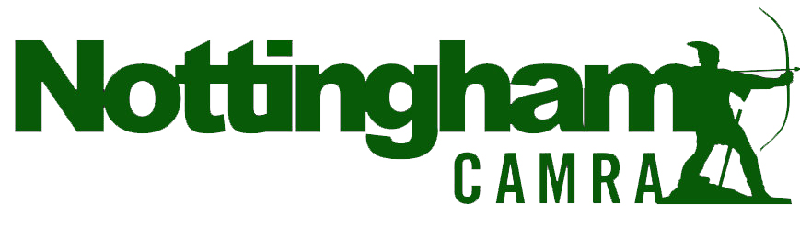
Press release Tuesday 13 February 2024

2024 HUCKNALL BEER & CIDER FESTIVAL

WINNER: SPYKE GOLDING CHALLENGE SHIELD
…….

The annual Hucknall Beer & Cider Festival took place between Thursday 8th and Sunday 11th February. The Festival is held at the John Godber Centre, a community venue at the heart of Hucknall, owned by The St Mary Magdalene Church and governed by the Church Council.

The 2024 festival hosted the Spyke Golding Challenge which involved eleven Nottinghamshire breweries submitting new and original beers which would be judged by the paying public. To make it a fair and open competition, only the tasting notes for the beers were provided with the brewery names being revealed on Saturday – after the judging had been completed.

Judges were asked to score out of 10 how close the beer matched the tasting notes and also a score based on: ‘Would they buy the beer in a pub?’. After extensive judging over two days the winner of the competition was:

Lenton Lane Brewery with their entry – ‘Escape’

A smooth 5.0% ABV pale ale packed with fruity undertones and tropical flavours

Jack Winter, Head Brewer said:

“ I have to start by mentioning Ant from Adventure Beer Company who collaborated with us on Escape and came up with the initial idea of this award winning beer - it certainly wouldn't have happened without him. We'd also like to thank everyone involved with Hucknall Beer Festival, Nottingham CAMRA and all of our customers for their continued support. It means a lot to our small team and it's always a bonus when we have been voted for by the drinkers of the festival and our fellow brewers. The standard of competition was extremely high this year and that is a credit to the Nottingham beer scene, a scene we are incredibly proud to be part of!”

The scoring was so high that three other entries were awarded ‘Highly Commended’
- Blue Monkey Brewery with an 8.0% RaspBEERy Wheat beer.
- Black Iris Brewery with ‘Highseas’ a 7.0% ABV strong dark export Porter
- Magpie Brewery with ‘Cavern Dweller’ a 4.2% ABV Hoppy mid-strength Pale Ale

The organisers wish to thank Milestone; Nottingham; Beer Mats; Shipstone/Hollowstone; Lincoln Green; Welbeck Abbey and Liquid Light breweries for also submitting beers for the competition. All of the beers were well received and all sold out. Full details of each beer and from which brewery it came from can be found on the Hucknall Beer Festival website http://www.johngodbercentre.co.uk/hucknall-beer-festival-the-drinks/
The Festival also offered a great selection of Ciders opening with initially 11 ciders and four perries, from makers near and far across England and Wales. Cider Bar organiser Ray Blockley of Torkard Cider in Hucknall explained that:

“The focus was on full- or whole-juice natural products made solely from apples or pears by small independent craft makers. We based the volume ordered on previous years - but ordered a higher overall volume with a mind on last year’s sell out; we also had some extra in reserve! This ensured we still had a range of both cider and perry available on the bar until close on Sunday, along with some of our reserve “just in case” stock.
Once again there was great interest in the local & regional makers we featured on the bar. In 2025 we hope to further the interest in quality whole-juice cider and perry, and meet the needs of our growing band of cider drinking visitors.”

Kim Pears, Manager of the John Godber Centre said

“We were so excited that the Nottingham CAMRA challenge was held at the Hucknall Beer Festival and that it featured 11 never before tried beers to be enjoyed and judged by real ale fans. Only a few of us got to see the entry list in advance and it was fascinating to talk to real ale fans and brewers over the weekend trying to guess who have brewed them. We’re so pleased these great selection of beers were sampled first in Hucknall at the festival in the John Godber Centre and we look forward to trying them in local pubs soon.

Thank you to everyone who supported the event and the challenge and we look forward to the 2025 event”

Notes to editors

The Hucknall Beer Festival is a charity fundraiser for the John Godber Centre. Further details can be found here - http://www.johngodbercentre.co.uk/hucknall-beer-festival/

Further Press quotes from Andrew Ludlow (Branch Sec) 07775 603091

Ray Blockley 07817 240940

Kim Pears, Manager 07961289733

